Office Use:

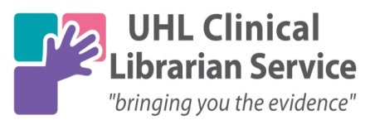

Article Request Form
We have been unable to obtain your article(s), however it is likely that the British Library can provide a single copy of each article. In order for us to purchase them, you will need to:
- Complete the copyright declaration below and return to us using a secure email such as @uhl-tr.nhs.uk / .nhs.uk / @doctors.org
- Create a British Library On Demand Account https://ondemand.bl.uk/onDemand/home
- Download your article within 30 days of receiving your email link from the British Library. If you do not download within 30 days, the article and fee paid will be lost.
- If the request expires and you wish the article to be reordered, the British Library charge of £12.00 per article will be passed on and payment will need to be received before the article is re-requested.
Article Details (Please include title, author, year, issue, pages and journal name)
1
2
3
OR
☐ All of the articles in the attached list.
I confirm that I wish UHL Libraries & Information Services to order the above articles on my behalf. I will download any articles within 30 days, and I declare that:
a) I have not previously been supplied with a copy of the same material by you or any other librarian;
b) I will not use the copy except for research for a non-commercial purpose or private study and will not supply the copy to any other person; and
c) to the best of my knowledge, no other person with whom I work or study has made or intends to make, at or about the same time as this request, a request for substantially the same material for substantially the same purpose.

I understand that if the declaration is false in a material particular, the copy supplied to me by you will be an infringing copy, and that I shall be liable for infringement of copyright as if I had made the copy myself.

Name: ______________________________________
E-Mail: ______________________________________
Date: ________________________________________
If you require multiple copies of an article e.g. for a journal club, please let us know so that we can provide a copyright-cleared version.
If you have difficulty accessing your article please contact the British Library Customer Services on 01937 546060 or Customer-Services@bl.uk
Please specify which organisation you work for: UHL☐ LPT☐ LCC Public Health☐ Other☐

